SDG 4 – Quality Education Project

Title: AI-Powered Early Warning & Academic Support System

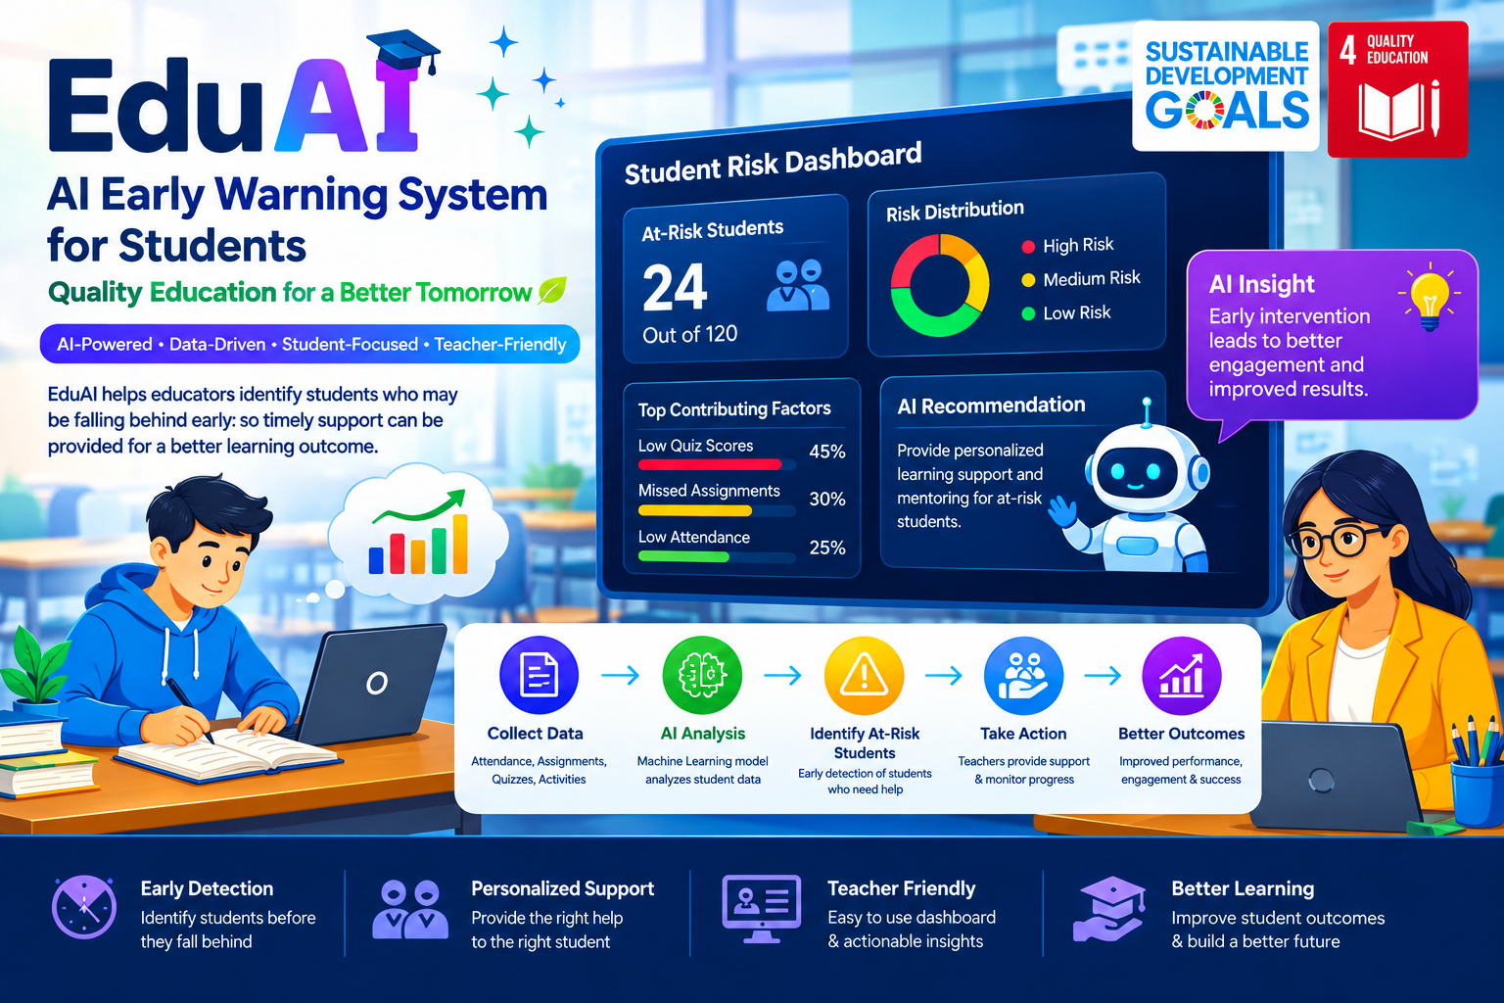

1. Introduction

Education plays an important role in improving individual and social development. However, some students may gradually fall behind in their studies because their academic difficulties are not identified early. If support is provided only after performance has declined significantly, it may become more difficult to close learning gaps.

To address this challenge, EduAI is designed as an AI-powered academic early warning and support system. The system uses Machine Learning to identify students who may require additional academic attention and uses IBM Granite Generative AI to provide personalized support recommendations.

The project is developed using synthetic student data and is intended as a demonstration of how AI can support educators in making earlier and more informed academic interventions.

2. Problem Statement
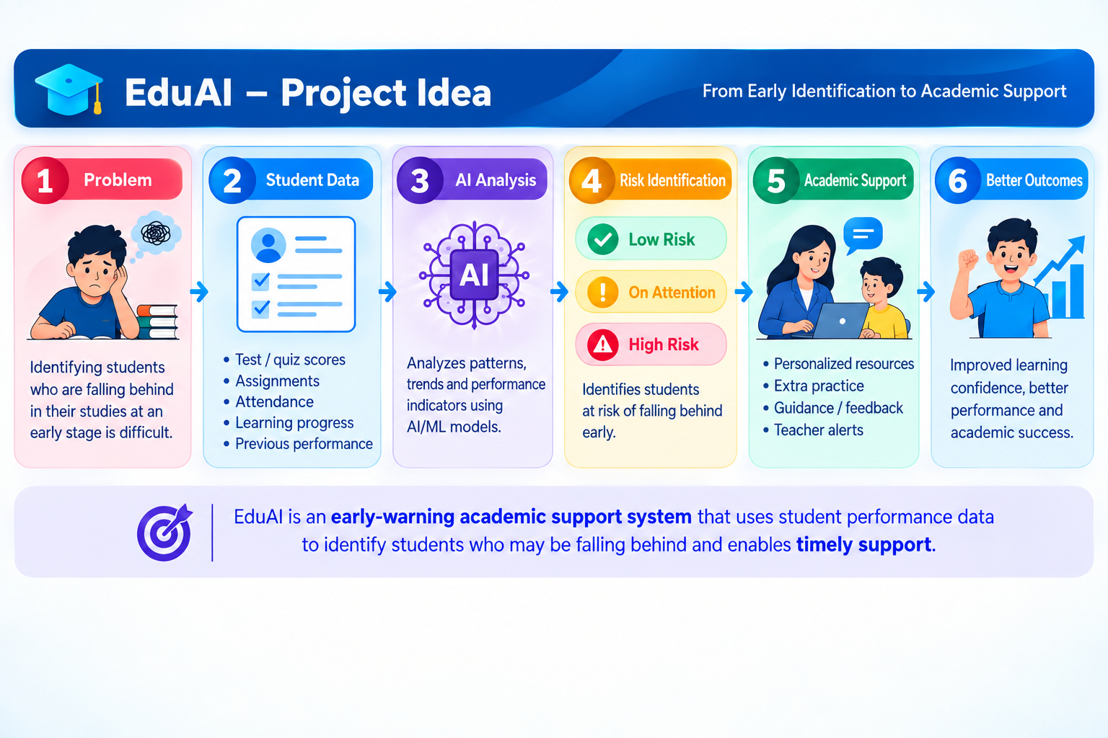

Identifying students who are falling behind in their studies at an early stage.

Students who are falling behind may not always be identified immediately. When academic difficulties are recognized late, the support they need may also be delayed. This can allow learning gaps to become larger over time.

Therefore, there is a need for a system that can analyze available academic indicators and help educators identify students who may need attention at an earlier stage.

3. Impact of the Problem

Late identification of academic difficulties can create several challenges:

Students may continue struggling without timely support.

Learning gaps may become larger over time.

Teachers may find it difficult to identify every student who needs additional attention.

Academic performance may continue to decline before intervention is provided.

Students may not receive the same level of academic support at the right time.

An early warning approach can help educators prioritize their attention and provide support before difficulties become more severe.

4. Proposed AI Solution

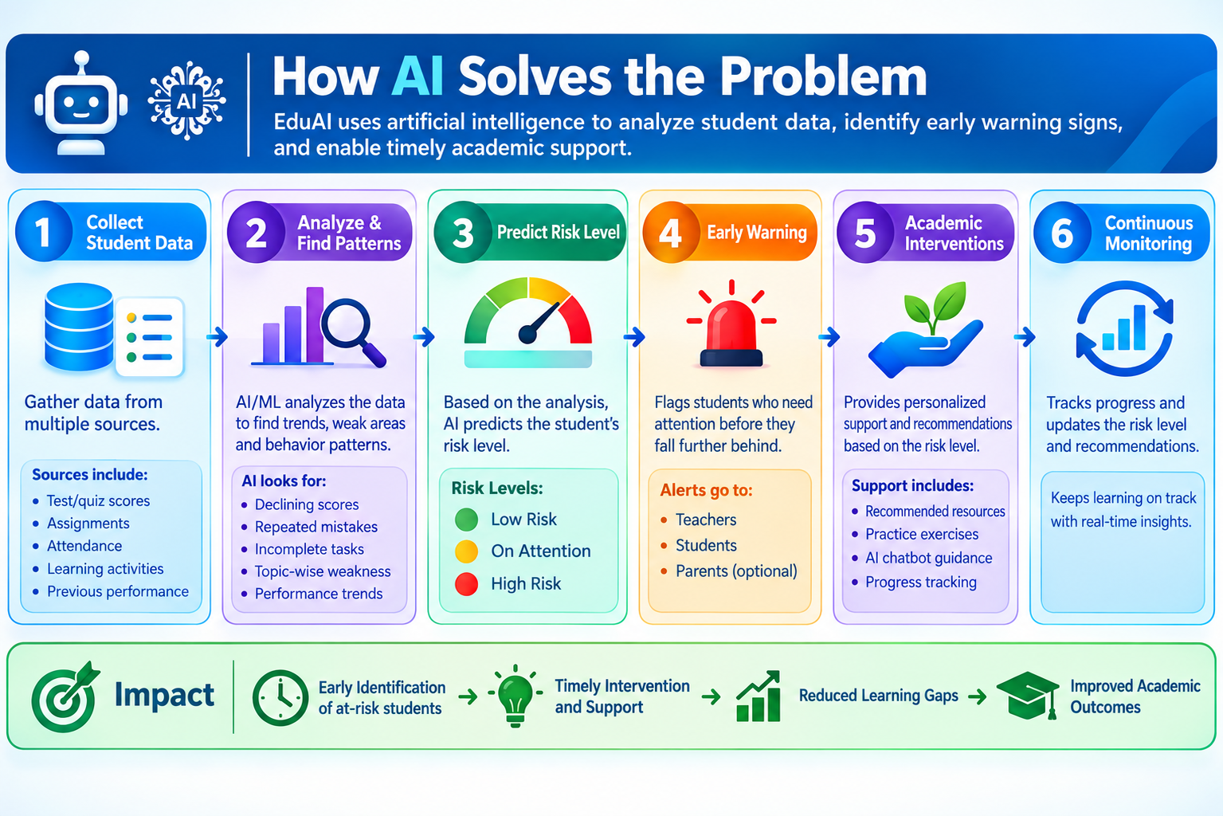

EduAI combines Machine Learning and Generative AI to support early identification and academic intervention.

The system analyzes student learning indicators such as:

Marks

Attendance

Quiz scores

Assignment completion

Previous marks

A Random Forest Classification model analyzes these indicators and classifies students into three risk levels:

On Track – The student is currently showing satisfactory indicators.

Needs Attention – The student shows indicators that may require additional monitoring or support.

At Risk – The student shows stronger indicators of academic difficulty and may require early intervention.

After identifying the risk level and relevant risk factors, IBM Granite generates an explanation and personalized academic recommendations.

The final result is presented through a Streamlit dashboard, allowing educators to understand the student's risk level and possible support actions.

5. How the AI System Works

The complete workflow follows these stages:

Student Data → Data Processing → Risk Analysis → Random Forest Prediction → Risk Classification → Risk Factor Identification → IBM Granite Recommendations → Streamlit Dashboard → Teacher Intervention

Step 1: Student Data

The system uses synthetic student data containing academic and engagement indicators. The project uses 500 synthetic student records, ensuring that no real student information is involved.

Step 2: Data Processing

The data is validated and prepared before being provided to the Machine Learning model. This helps ensure that the information is in a suitable format for analysis.

Step 3: Machine Learning Prediction

A Random Forest Classifier is trained to identify the academic risk category of a student.

The model uses multiple student indicators to recognize patterns associated with different risk levels.

Step 4: Risk Classification

Based on the prediction, students are classified as:

On Track → Needs Attention → At Risk

This classification helps educators prioritize students who may require additional monitoring or intervention.

Step 5: Risk Factor Identification

The system also identifies observable factors contributing to the student's risk level, such as:

Low marks

Low attendance

Low quiz performance

Low assignment completion

Declining academic performance

This makes the prediction more understandable instead of presenting only a risk label.

6. Role of IBM Granite

IBM Granite is used as the Generative AI component of the system.

After the student's risk level and relevant factors are identified, Granite generates:

An explanation of the student's situation

Three personalized recommendations

A monitoring suggestion

For example, instead of simply showing that a student is At Risk, the system can provide recommendations focused on areas such as improving attendance, completing assignments, or receiving additional academic practice.

This allows the system to move from prediction to actionable support.

7. Streamlit Dashboard

A Streamlit dashboard is used to present the system results in an accessible interface.

The dashboard can display:

Student information

Predicted risk level

Identified risk factors

AI-generated recommendations

Monitoring suggestions

This provides educators with a simple way to interpret the AI output and decide what type of academic support may be appropriate.

8. Model Performance

The Random Forest model was evaluated using standard classification metrics.

The project achieved:

Accuracy: 97.0%

Macro Precision: 97.7%

Macro Recall: 97.1%

Macro F1 Score: 97.3%

These results indicate strong performance on the project's synthetic demonstration dataset.

9. Expected Impact

The proposed system can support education in several ways.

Early Support:
Students who show signs of difficulty can be identified before their learning gaps become larger.

Better Teaching Decisions:
Educators can prioritize students who may require additional attention.

Reduced Learning Gaps:
Earlier intervention can help address academic difficulties sooner.

Inclusive Education:
Students can receive more timely and targeted academic support.

Sustainable Education:
AI-assisted early intervention can contribute to a more inclusive and equitable education system.

10. Connection to SDG 4 – Quality Education

This project is connected to Sustainable Development Goal 4 (SDG 4): Quality Education.

SDG 4 focuses on ensuring inclusive and equitable quality education and promoting learning opportunities.

EduAI supports this goal by using AI to help identify students who may need academic support and by providing recommendations that can assist educators in responding earlier.

The project demonstrates how technology can be used not only to analyze educational data but also to support more inclusive and student-focused educational practices.

11. Ethical Considerations

The project follows several responsible AI principles:

Only synthetic student data is used.

No real student personal information is required.

Risk factors are transparent and based on observable academic indicators.

The AI system supports educators rather than replacing them.

The system does not make assumptions about a student's medical, family, financial, or social circumstances.

Risk categories should not be treated as permanent labels.

AI-generated recommendations should be reviewed by educators before action is taken.

12. Conclusion

EduAI demonstrates how Artificial Intelligence can be applied to an educational challenge through an early warning and academic support approach. By combining Random Forest Machine Learning with IBM Granite Generative AI, the system can identify potential academic risk, explain observable risk factors, and generate personalized recommendations.

The main objective is not to replace teachers, but to provide them with an additional tool for identifying students who may need attention earlier. By supporting timely intervention and more targeted academic assistance, the project contributes to the broader objective of SDG 4 – Quality Education.

Overall, EduAI shows how AI can be used responsibly to support early academic intervention, reduce learning gaps, and promote more inclusive and equitable educational opportunities.

